P250/1
Physical Geography
Paper 1
July/August 2019
3hours

BUGANDA EXAMINATION COUNCIL MOCKS

Uganda Advanced Certificate of Education

GEOGRAPHY

(PHYSICAL GEOGRAPHY)

PAPER 1

3HOURS
INSTRUCTIONS TO CANDIDATES
- This paper consists of three sections A, B and C.
- Answer four questions
- Section A question 1 and 2 are compulsory
- Answer one question from section B and one question from section C.
- Credit will be given for the use of relevant sketch maps, diagrams and specific examples in the field.
- Any additional question(s) will not be marked.

1. Study the 1:50,000 (UGANDA) KATUNGULU map extract, series Y732; part of sheet 93/3; Edition 4 – U.S.D and answer the questions that follow;

(a)(i) Identify the man made feature found at grid reference 717857
(ii) State the Height of hill peak at grid reference 852763 (2marks)

(b) Describe the drainage pattern shown by River Katerera in the South East. (3marks)

(c)(i) Draw a cross section of the area between grid reference 850750 and 874830 on it mark and name;
(a) rivers
(b) thicket
(iii) crater
(iv) footpath
(v) forest and county boundary (8marks)

(ii) Calculate the vertical exaggeration of the section. (2marks)

(d) Describe the relationship between;
(i) drainage and communication
(ii) relief and vegetation (8marks)

COMPULSORY PHOTOGRAPHIC INTERPRETATION
Study the photograph and answer the questions that follow:
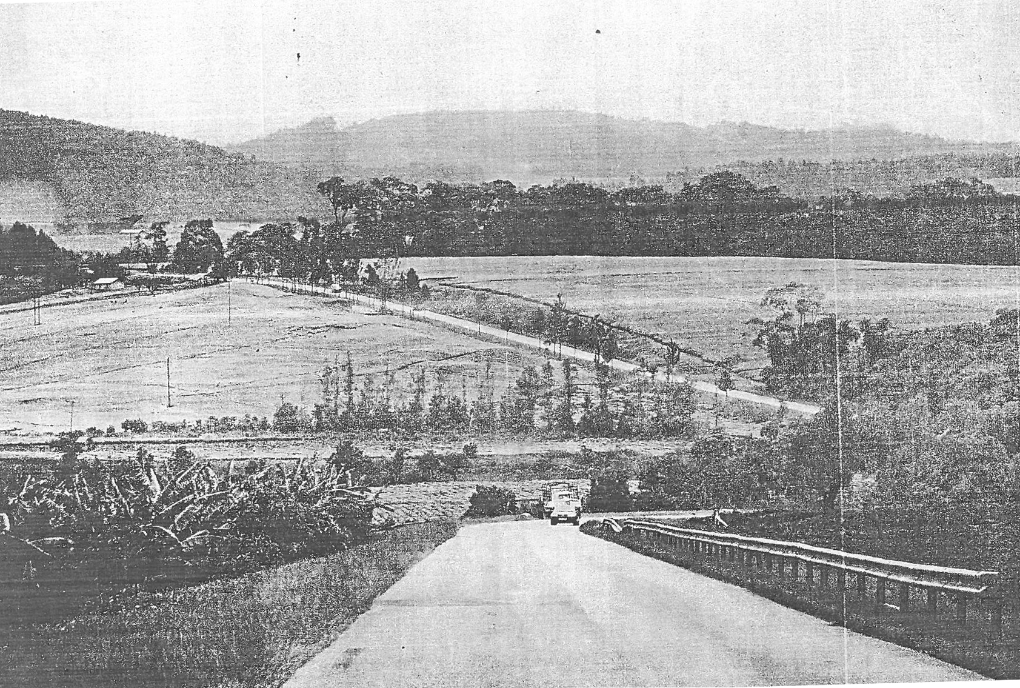
2(a) Draw a landscape sketch of the area shown on the photography on it mark and name the;
(i) physiographic regions
(ii) vegetation types
(iii) land use types (9marks)

(b) Describe the nature of landscape in the area on the photograph. (3marks)
(c) Describe the relationship between relief and land use on the area shown on the photograph. (6marks)

(d)(i) Examine the problems faced by people living in the area shown in the photograph. (5marks)

(ii) Giving reasons for your answer, suggest an area in East Africa where the photograph could have been taken. (2marks)

SECTION B
3(a) Distinguish between a Sill and Dyke. (6marks)
(b) Examine the influence of intrusive vulcanicity on the development of relief land forms in East Africa. (19marks)

4. Explain the influence of denudational processes on formation of lakes in East Africa.
(25marks)
5. With reference to specific examples from East Africa. Account for the formation of the landforms of submergence on the coast. (25marks)

SECTION C

6(a) Distinguish between Anabatic and Katabatic winds. (16marks)
(b) Describe the weather conditions associated with;
(i) Anabatic winds
(ii) Katabatic winds (9marks)

7(a) Describe the characteristics of mangrove forest vegetation. (10marks)
(b) Explain the conditions that have influenced the distribution of mangrove forests.
(15marks)
8(a) What is meant by soil catena? (10marks)

(b) With reference to specific examples, account for the development of soil catena in East Africa. (15marks)
END

